On Delete executed below Actions :

When we unpublished any articles then Delete Action executed .

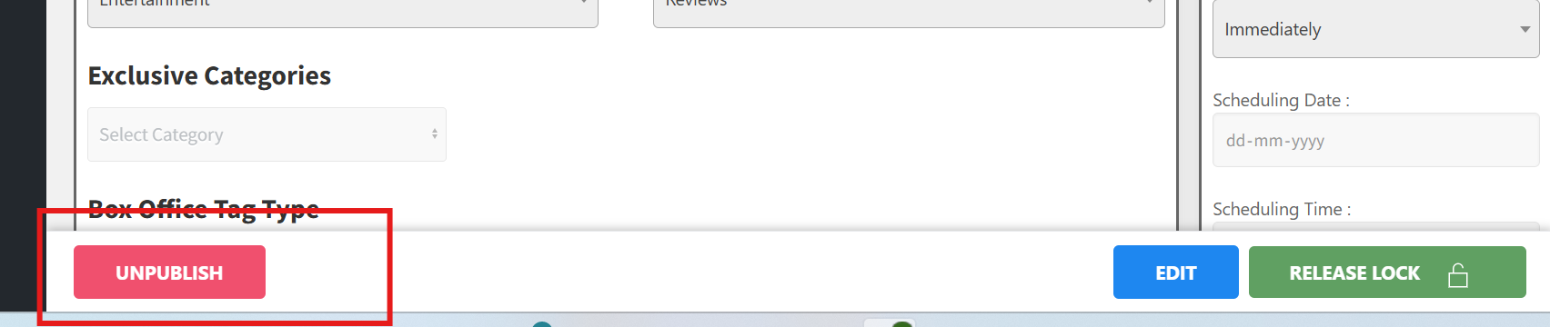

When click on UNPUBLISH Button Then Popup , Show below

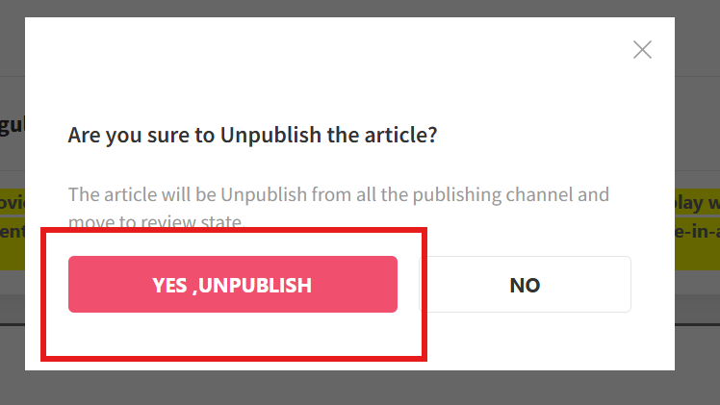

When clicking “YES , UNPUBLISH” Button then action below Function.

Line number 3350

Function updateStatusWorkspace

Then we applied below Action :

- Clear Home page Cache
- Clear latest listing page Cache
- Clear section and subsection page Cache
- Author page Cache
- Home Page Cron (var/projects/englishcmsdocroot/cron/script_pv_homepageV3.php)

